Exploring commands: Step-by-step exercises
In the following exercises, you will explore the use of command-line utilities in Windows PowerShell. You will find that it is as easy to use command-line utilities in Windows PowerShell as in the CMD interpreter; however, by using such commands in Windows PowerShell, you gain access to new levels of functionality.
Using command-line utilities
1. Open Windows PowerShell by choosing Start | Run | PowerShell. The Windows PowerShell prompt opens by default at the root of your user folder.
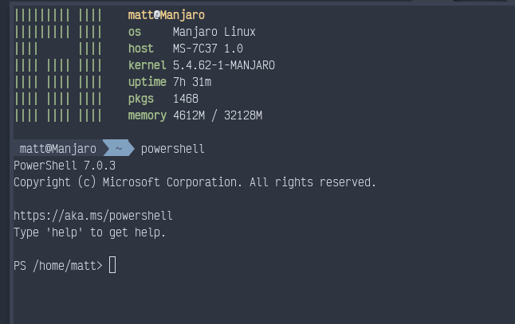
2. Change to the root of C:\ by entering cd c:\ inside the Windows PowerShell prompt.
cd c:\
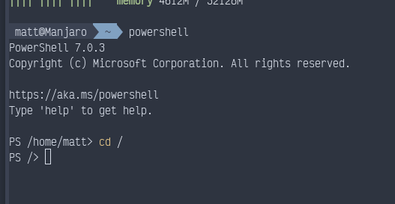
3. Obtain a listing of all the files in the root of C:\ by using the dir command.
Dir
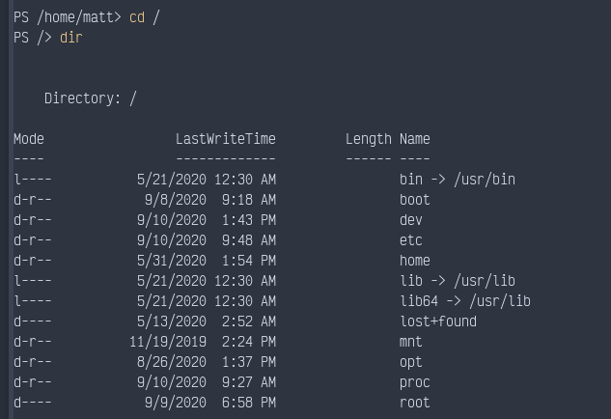
4. Create a directory off the root of C:\ by using the md command.
md mytest
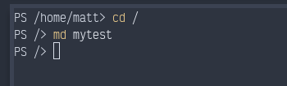
5. Obtain a listing of all files and folders off the root that begin with the letter m.
dir m*
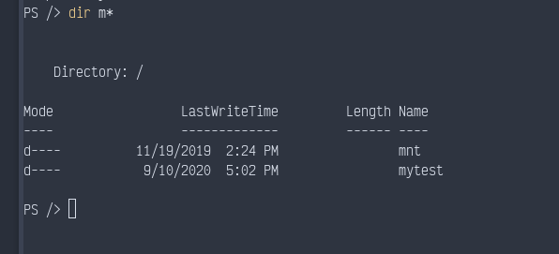
6. Change the working directory to the Windows PowerShell working directory. You can do this by using the Set-Location command, as follows.
Set-Location $pshome
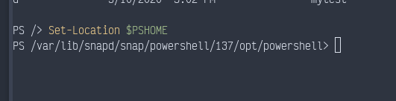
7. Obtain a listing of memory counters related to the available bytes by using the typeperf.exe command.
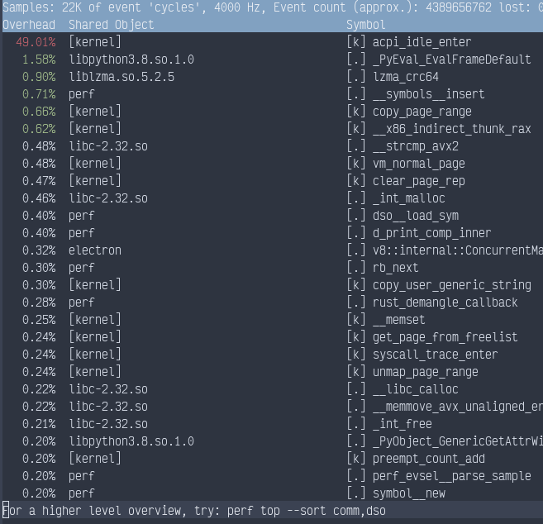

Insert command and screen shot of results

8. After a few counters have been displayed in the Windows PowerShell window, press Ctrl+C to break the listing.
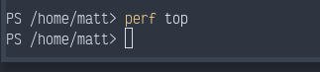
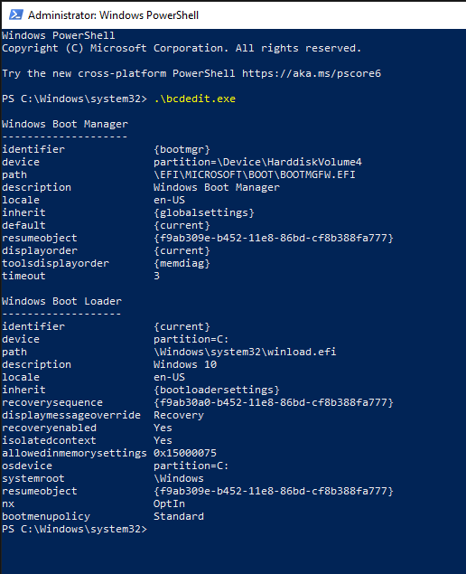
9. Display the current startup configuration by using the bcdedit command (note that you must run this command with admin rights).

Insert command and screen shot of results

10. Change the working directory back to the C:\Mytest directory you created earlier.
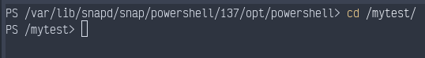

Insert command and screen shot of results
11. Create a file named mytestfile.txt in the C:\Mytest directory. Use the fsutil utility, and make the file 1,000 bytes in size.
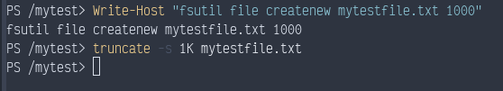
Insert command and screen shot of results

12. Obtain a directory listing of all the files in the C:\Mytest directory by using the Get-ChildItem cmdlet.
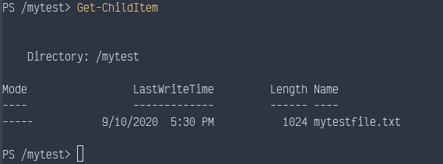
13. Print the current date by using the Get-Date cmdlet.
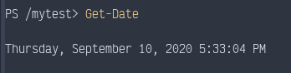
14. Clear the screen by using the cls command.
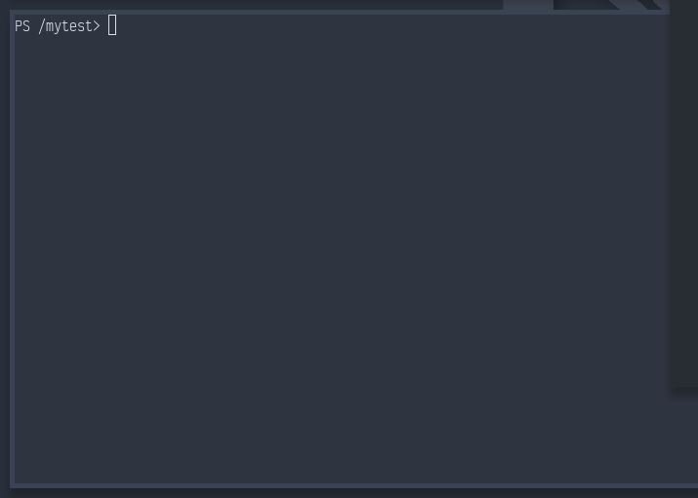
15. Print a listing of all the cmdlets built into Windows PowerShell. To do this, use the Get-Command cmdlet.
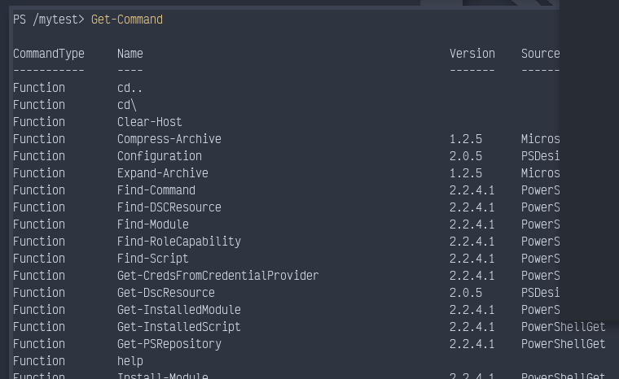
16. Use the Get-Command cmdlet to get the Get-Alias cmdlet. To do this, use the -Name parameter while supplying Get-Alias as the value for the parameter. This is shown here.
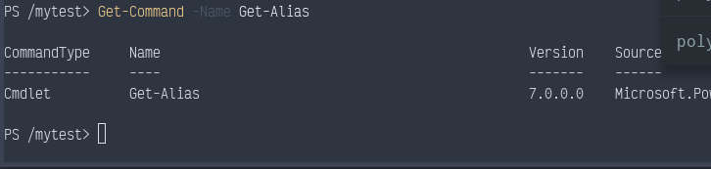
Insert command and screen shot of results

